Revision Problems - ORGANIC CHEMISTRY - 2

Aldehydes, ketones, carboxylic acids
12.1. For each of the following, identify the type of organic compound and then name it.
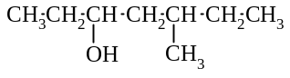
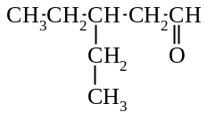
a) b)

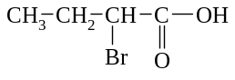
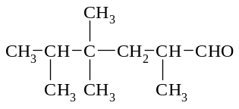
c) d)

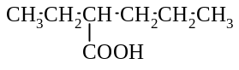
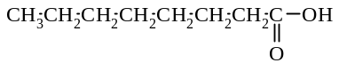
e) f)
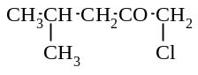
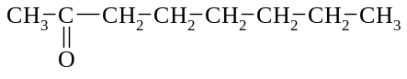
g) h)

2.2. Draw the structural formulae of the following compounds:
a) pentanal b) 2-methylbutan-2-ol c) 3-bromo-3-ethylhexan-2-amine
d) 2,2-dichlorooctan-4-one e) 4-chloro-5-methylhexanoic acid

12.3. Give the name and formula of the organic compound formed in each of the following reactions:

Reaction mixture | Name of product | Formula of product
a) CH₃ CH₂ CH₂ OH is mixed with an acidified solution of potassium permanganate for a short time, and the product is then removed from the reaction mixture by distillation.
b) CH₃ CH₂ CH₂ CH₂ CH₂ OH is boiled with an acidified
solution of potassium dichromate
c) hexan-3-ol is reacted with an acidified solution of sodium
dichromate
d) 2-methylbutan-2-ol is boiled with a solution of potassium
permanganate.
e)
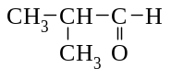

is heated with an acidified solution of potassium dichromate
f) pentan-3-ol is mixed with an acidified solution of potassium permanganate and the mixture is heated.

12.4. First write the two relevant half equations, then derive the overall ionic equation for each of the following reactions
(use structural formulae for the organic compounds):
a) propan-2-ol is heated with an acidified solution of potassium permanganate
b) butan-1-ol is mixed for a short time with an acidified solution of sodium dichromate
c) pentanal is heated with an acidified solution of potassium permanganate
d) 3-methylpentan-3-ol is heated with an acidified solution of potassium permanganate
e) propan-1-ol is mixed and boiled with an acidified solution of sodium dichromate

Esters
12.5. Give the structural formulae and names of the esters that are formed when the following carboxylic acids and
alcohols react:
a) CH₃ - CO - OH + HO - CH₂ - CH₂ - CH₃ →
b) CH₃ - CH₂ - CH₃ - CO - OH + CH₃ CH₂ OH →
c) CH₃ CH₂ CH₂ COOH + CH₃ OH →

12.6. Name the following esters:
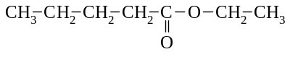
a) b) CH₃ CH₂ COO CH₂ CH₂ CH₃
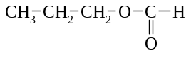
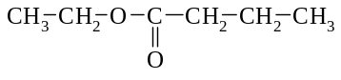
c) d)

12.7. Give the structural formulae of the following:
a) propyl ethanoate b) ethyl hexanoate

12.8. Give the formulae of the organic compounds that are formed in the following reactions:
a) methyl ethanoate is boiled with a solution of hydrochloric acid
b) 1-propyl butanoate is heated with a solution of sodium hydroxide

12.9. Give the formulae and names of the isomers with the following molecular formulae:
a) C₃H₈O b) C₃H₆O c) C₃H₆O₂

Polymers, soaps & detergents
12.10. Draw a small portion of the polymer formed when the following alkenes polymerise:
a) tetrachloroethene b) CH₃ - CH = CH₂ c) (styrene)
CH₂ = CH

12.11. Draw a small portion of the condensation polymer formed when the following monomers react:
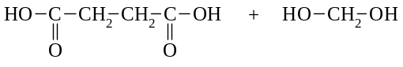
a) b) propane-1,3-diol + pentanedioic acid

12.12. Give the structural formulae of the monomers used to make each of the following polymers:
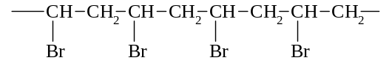
a)

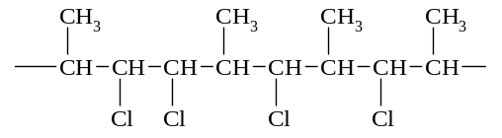

b)

c)

d)

12.13. Identify the following as a detergent, a soap , a fatty acid, a fat or glycerol:
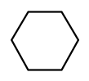
SO₃⁻ Na⁺
CH₃ (CH₂)_{n}
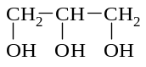
a) b)

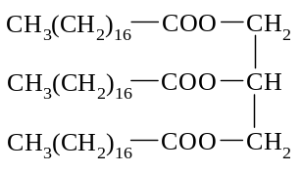
c) d) CH₃(CH₂)₁₆ - COO⁻ Na⁺

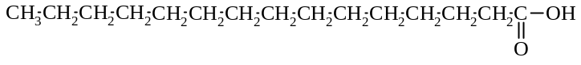
e)

Empirical formulae
12.14. a) An organic compound is found to contain 92.25% carbon and 7.75% hydrogen. If the molecular mass is 78,
what is the molecular formula?
b) In the absence of a catalyst, the compound does not react with bromine in the presence or absence of sunlight. Propose a structural formula for the compound.

12.15. A sample of a compound containing carbon, hydrogen and nitrogen only was burned in oxygen and produced
264 g of carbon dioxide , 63.0 g of water and 46.0 g of nitrogen dioxide.
a) Calculate the empirical formula of the compound.
b) If the molecular mass of the compound is approximately 95 , calculate the molecular formula of the compound.
c) If the compound is an aromatic substance, propose a structural formula of this compound.

12.16. An 11.0 mg sample of an organic compound containing carbon, hydrogen and oxygen only was burned in an excess of oxygen and yielded 26.4 mg of CO₂ and 5.40 mg of H₂O. Calculate the empirical formula of the compound

TEE Questions
12.17. The following is the structural formula of the natural oil geraniol.
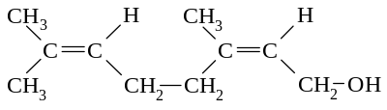

Which one of the following statements about geraniol is false?
A Cis/trans isomerism can occur about each of the double bonds.
B It is an alcohol.
C It will decolourise a water-solution containing potassium permanganate and sulfuric acid.
D It will decolourise bromine water.
E With controlled oxidation, the - CH₂OH group of geraniol can be converted into -COOH.

12.18. Only one of the following is a correct formula. Which is it?
A CH₃ - OH - CH₂ - CH₃ B CH₃ - CH₂ = CH₂ - CH₃
C CH₃ - CH₃ - CH - CO - C(CH₃)₃ D CH₃ - CH₂ - NH₂ - CH = CH₂
E (CH₃)₂CH₂

12.19. Which one of the following compounds can be oxidised to form a ketone?
A CH₃OH B CH₃CH₂OH C CH₃CH₂CH₂OH D CH₃CH₂CHOHCH₃ E (CH₃)₃COH

12.20. The following is part of the structure of a polymer.
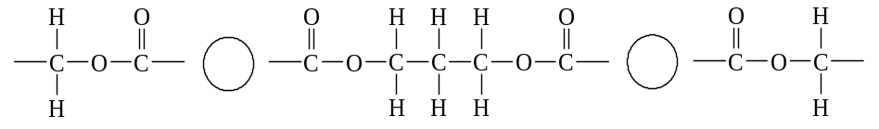

Draw a structural formula for each of the monomers needed to produce the polymer.

12.21. A pure substance ‘A’ is a colourless liquid which boils at 57ºC and has a strong odour. ‘A’ burns readily in air leaving no ash, and qualitative analysis shows that nitrogen, sulfur, and the halogens are absent. It may thus be
concluded that ‘A’ contains the elements carbon and hydrogen and possibly oxygen.
a) In an experiment, 0.6047 g of ‘A’ is burnt in a current of dry air, and 1.078 g of carbon dioxide and 0.441 g of
water are produced. Calculate the empirical formula of ‘A’.
b) At 100ºC and 1.00 atm pressure, 0.1367 g of ‘A’ evaporates to occupy a volume of 57 mL. Calculate the
molecular weight of ‘A’.
c) What is the molecular formula of ‘A’?
d) A nuclear magnetic resonance spectrum of ‘A’ indicates that all the H atoms in ‘A’ are in methyl groups. Draw the structural formula for ‘A’.

12.22. Many compounds have the empirical formula C₃H₆O. Draw the structural formulae for a ketone, an aldehyde, a carboxylic acid and an ester which have this empirical formula. Name each compound.

12.23. Draw a structural formula for a section of the polymer that is made from the monomer vinyl chloride (chloroethene), CH₂CHCl. The section must contain at least 6 carbon atoms. All bonds must be shown.

12.24. A pure substance ‘A’ is a white solid, melting at 153ºC, which is found by qualitative analysis to contain carbon and hydrogen. With no simple test for oxygen available, it can be assumed oxygen might be present.
When 0.8062 g of ‘A’ is burnt in a current of dry oxygen, 1.110 g of carbon dioxide and 0.303 g of water are produced. Calculate the empirical formula of ‘A’.

12.25. Which one of the following is the formula of an aromatic compound?
CH₃
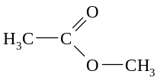
A B C

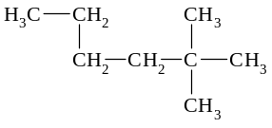
D E

12.26. Which one of the following substances can be made from just the materials listed?
Substance Starting materials
A propyl ethanoate propanoic acid, ethanol, and concentrated sulfuric acid
B propanal propanoic acid, potassium permanganate, and dilute sulfuric acid
C polyvinyl chloride dichloroethane and a catalyst
D soap concentrated sodium hydroxide solution and glycerol
E ethanoic acid ethanal, sodium dichromate, and dilute sulfuric acid

12.27. Write equations for any reactions that occur in the following procedures.
In each case describe in full what you would observe, including any colours, odours, precipitates (give the colour), gases evolved (give the colour or describe as colourless)
If a reaction occurs but the change is not visible, you should state this.
a) A little concentrated sulfuric acid is added to a mixture of methanol and acetic acid (ethanoic acid) and the
mixture is heated.
b) Dilute hydrochloric acid is added to sodium acetate (sodium ethanoate) solution.

12.28. Identify by name or formula an example of each of the following.
a) A diprotic acid b) A colourless redox primary standard
c) An aromatic acid d) A negatively charged complex ion

12.29. Stearate ion is present in soapy water, and has the following structure
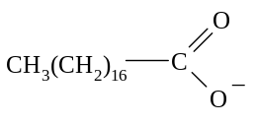

Draw the structural formula for the organic species that is produced when 1 mol L⁻¹ HCl is added to the soap solution.

12.30. Work out the equation for the reaction that occurs when propan-2-ol is warmed with a water-solution containing
potassium dichromate and sulfuric acid.
Oxidation half-equation

Reduction half-equation

Redox equation

12.31. For each of the following pairs of compounds, describe a chemical test to distinguish between them. Give all the steps, but equations are not required.

 | Your chemical test. Describe fully | What you would observe in each case
Cu(NO₃)₂ |  | with Cu(NO₃)₂
and  CuSO₄ |  | with CuSO₄
MgCl₂ |  | with MgCl₂
and  ZnCl₂ |  | with ZnCl₂
CH₃CH₂OH |  | with CH₃CH₂OH
and  CH₃COOH |  | with CH₃COOH

12.32. Work out the equation for the reaction that occurs when ethanal (acetaldehyde) is warmed with water-solution
containing potassium dichromate and sulfuric acid.
Oxidation half-equation

Reduction half-equation

Redox equation

12.33. One or more of the following compounds can be used industrially to produce a polymer.
COOH
COOH
COOH
CH₃CH₂ - OH HO - CH₂CH₂ - OH

Draw a structural formula showing part of this polymer, including in your diagram as least four monomer units.

12.34. Write the systematic (IUPAC) name of each of the following:
a) | 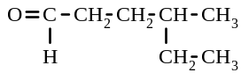 | b) | 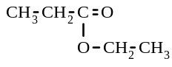
c) | 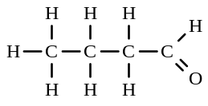 | d) | 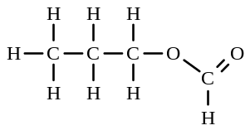

12.35. The following diagram shows part of a polymer molecule
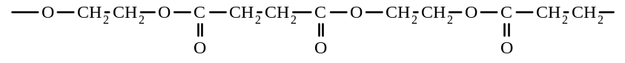
a) Draw structural formulae for the two monomer molecules which combine to form the polymer.
b) Name the type of polymerisation process involved.
c) Give the formula of the substance which is produced in the polymerisation, besides the polymer.

12.36. a) A pure compound, which is a colourless liquid at room temperature, boils at 138ºC, and analysis shows it to
contain 90.49% carbon and 9.48% hydrogen by mass. Calculate the empirical formula of the compound.
b) Explain why the empirical formula calculated in a) cannot be its molecular formula.
c) A known mass of the liquid is vaporised, and from the volume of gas produced the molecular weight of the
compound is calculated to be about 105. What is the molecular formula of the compound.
d) The odour of the liquid, and the smoky flame when a sample is burned, indicates that the compound is aromatic. Draw one of the four possible structural formulae for the compound.

12.37. Which one of the following is an esterification reaction?
A CH₃CH₂CH₃ + Br₂ → CH₃CH₂CH₂Br + HBr
B CH₃COOH + CH₃OH → CH₃COOCH₃ + H₂O
C CH₃CHCH₂ + HBr → CH₃CH₂CH₂Br
D CH₃COOCH₃ + OH⁻ → CH₃COO⁻ + CH₃OH
E CH₃COOH + OH⁻ → CH₃COO⁻ + H₂O

12.38. Which two of the following substances are commonly used in the manufacture of soap?
I A long chain fatty acid II A natural oil III Sodium hydroxide IV Stearic acid
A I and II B I and III C II and III D II and IV E III and IV

12.39. Which of the following could be used for cleaning purposes?
I CHCl₃ II A water solution of NH₃ III A water solution of CH₃(CH₂)₁₆COONa
A I only B II only C III only D I and II only E All of them

12.40. Examine this section of the structure of an addition polymer.
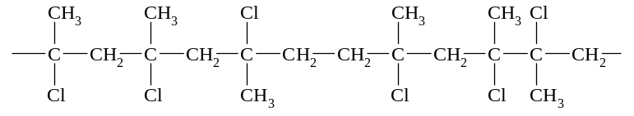

Which one of the following compounds could polymerise to form this chain?
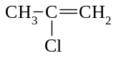
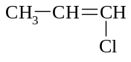
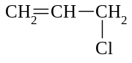
A B C

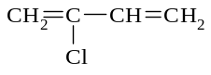
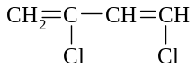
D E

12.41. Which one of the following is the correct classification of the molecule depicted here?
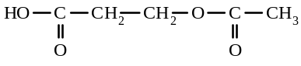
A Alcohol and aldehyde B Alcohol and ketone C Carboxylic acid and ketone D Carboxylic acid and ester E Dicarboxylic acid

12.42. | 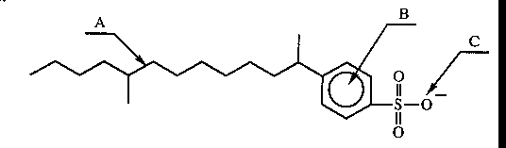
a) Which of the labelled arrows (A, B, C) on the diagram above indicates
i) the part of the ion where delocalised electrons may be found
ii) a hydrophobic group
iii) a hydrophilic group?
b) i) What common substances contain such an ion?
ii) In one or two sentences, state how the properties of this ion relate to its use.

12.43. An unknown organic compound Q is known to be a simple carboxylic acid. Its molecular weight is known to be 74.
a) Draw a complete structural formula for the compound Q including all hydrogen atoms. Give the IUPAC name.
b) Draw the structure of an ester which is isomeric with the unknown compound Q. Give the IUPAC name for the ester.

12.44. Substance A has the empirical formula C₂H₄O and is immiscible with water. When A is heated with 6 mol L⁻¹ sodium hydroxide solution, two substances B and C are produced. When C is treated with an acidified solution of potassium permanganate, a monoprotic acid D is formed. When D is neutralised with sodium hydroxide solution,
more substance B is produced. If the molecular weight of B is 82, write the names of substances A, B, C and D.

Miscellaneous multiple-choice problems

12.45 Which statement, concerning the following compound with the structure, is CORRECT?
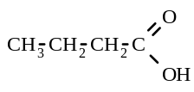
A Its name is propanoic acid B It forms an aqueous solution with a pH greater than 7.
C It is less soluble in water than pentanoic acid D It reacts with methanol to form methyl butanoate.
E It can be formed by dichromate oxidation of 2-butanol.

12.46 An ester is formed when propan-1-ol reacts with ethanoic acid, in the presence of sulfuric acid. The structural
formula of the ester formed in this reaction would be:
A CH₃ COO CH₂ CH₂ CH₃ B CH₃ CH₂ COO CH₂ CH₂ CH₃
C CH₃ CH₂ COO CH₂ CH₃ D CH₃ COO CH₂ CH₃
E CH₃ CH₂ CO CH₂ CH₃

12.47. Which one of the following compounds is a triprotic acid (i.e. can release three hydrogen ions into an aqueous
solution for each molecule of acid)?
A sulfuric acid B propanoic acid C nitric acid
D phosphoric acid E ammonia

12.48. Which one of the following statements is NOT true?
A Ethanol reacts with sodium to form hydrogen gas and sodium ethoxide.
B Oxidation of ethanol with potassium dichromate forms ethanoic acid
C Ethene reacts with chlorine to form chloroethane
D Propan-2-ol reacts with an acidified solution of potassium permanganate to form propanone
E Methylpropan-2-ol does not react with an acidified solution of potassium permanganate

12.49. The solubility of pentane, propan-1-ol and diethyl ether (CH₃CH₂OCH₂CH₃) in water in decreasing order are
A propan-1-ol > diethyl ether > pentane B diethyl ether > propan-1-ol > pentane
C diethyl ether > pentane > propan-1-ol D pentane > diethyl ether > propan-1-ol
E propan-1-ol > pentane > diethyl ether

12.50. When peanut oil and sodium hydroxide solution are boiled together for some time, the substances formed are
A soap and ethanol B soap and glycerol C soapless detergent and glycerol
D glycerol and sodium ethanoate E ethanol and fatty acids

12.51. The ‘cleaning’ properties of detergents depend on the fact that
A the hydrocarbon chain attracts oil molecules and the ionic head attracts water molecules
B the hydrocarbon chain attracts water molecules and the ionic head attracts oil molecules
C both the hydrocarbon chain and the ionic head attract the oil molecules only
D both the hydrocarbon chain and the ionic head attract the water molecules only.

12.52 The solubilities of potassium bromide in the given solvents, in decreasing order are
A water > ethanol > ether > octane B ethanol > water > ether > octane
C ethanol > water > octane > octane D ether > octane > ethanol > water
E water > ether > ethanol > octane
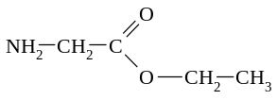

12.53. The compound is both

A an ester and an amine B an ester and a ketone C a ketone and an amine
D an ester and an ether E a carboxylic acid and an amine
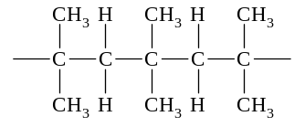
12.54. The monomer for the following polymer is

A but-1-ene B butane C propene D methylpropene E but-2-ene
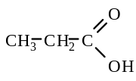

12.55. Which statement is FALSE concerning the compound with the structure ?

A Its name is propanoic acid
B It can be formed by dichromate oxidation of a primary alcohol
C It is more soluble in water than propane
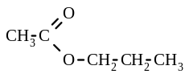
D It reacts with ethanol to form 1-propyl ethanoate,
E It is a weaker acid that nitric acid

12.56. When propanoic acid reacts with ethanol in the presence of sulfuric acid, the organic product formed has the
structural formula:
A CH₃CH₂CH₂COOCH₂CH₃ B CH₃COOCH₂CH₂CH₃ C CH₃CH₂COOCH₂CH₃
D CH₃CH₂COOCH₂CH₂CH₃ E CH₃COOCH₂CH₃

12.57. For the substances H₂O, CH₃CH₂OH, CH₃COCH₃ and CH₃CH₂CH₃, the strengths of the intermolecular forces, in
decreasing order are
A H₂O > CH₃CH₂OH > CH₃COCH₃ > CH₃CH₂CH₃
B CH₃CH₂OH > H₂O > CH₃COCH₃ > CH₃CH₂CH₃
C H₂O > CH₃CH₂OH > CH₃CH₂CH₃ > CH₃COCH₃
D CH₃CH₂OH > H₂O > CH₃CH₂CH₃ > CH₃COCH₃
E CH₃COCH₃ > H₂O > CH₃CH₂OH > CH₃CH₂CH₃
H⁺
12.58. The reaction CH₃CH₂COOH + CH₃OH CH₃CH₂COOCH₃ + H₂O is best described an example
of which one of the following types of reactions?
A addition B subtraction C neutralisation
D esterification E oxidation - reduction

12.59. Which functional groups are present in the following compound: ?
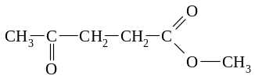

A one ester and one ketone B two ketone and one ether
C one carboxylic acid and one ketone D one aldehyde and one carboxylic acid
E one aldehyde and one ester
12.60. Non-polar organic solvents such as kerosene dissolve non-polar solids such as paraffin wax because
A the solvent reacts chemically with the solute
B intermolecular forces between solute and solvent molecules are similar to those within the pure solute and solvent
C very strong solute-solvent intermolecular forces exist
D the intermolecular forces between solvent molecules are very weak
E the solute and solvent are composed if the same chemical elements.

12.61. Ethanoic acid has the formula CH₃COOH. It would be incorrect to say that ethanoic acid
A is made up of three elements B contains 8 atoms per molecule
C has an empirical formula C₂H₄O₂ D is isomeric with methyl methanoate
E contains a carbon-oxygen double bond.

12.62. Which of the following would react with sodium hydroxide to form a product that can be used for washing grease from fabric?
I glycerol II safflower oil III long-chain organic acids
A II only B III only C I and II only D II and III only E I, II and III

12.63. Primary alcohols are readily oxidised by reagents such as acidified potassium dichromate to give aldehydes and , subsequently, carboxylic acids. These acids will react with the original primary alcohols to give esters. Which one of the following sequences represents such a set of organic reactions? (R represents an alkyl group such as
methyl, CH₃)
A R.CH(OH).R → R.CO.R → CO₂H → R.CO₂R
B R.COOR → R.CO₂R → R.CHO → R.CH₂OH
C R.CO.R → R.CH(OH).R → R.CH(O.COR).R → R.CO₂⁻
D R.CH₂OH → R.CHO → R.CO₂H → R.CO.OCH₂R

12.64. What functional groups are present in the following compound:
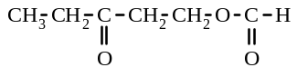

A two ketone and one ester B one ketone, one aldehyde and one ester
C two aldehyde and one ester D one aldehyde and one ester
E one ketone and one ester

12.65. Which of the following compounds are isomeric with ethyl ethanoate?
I | II | III
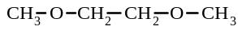 | 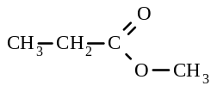 | 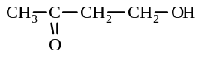
A I only B II only C III only D II and III only E I and II only

12.66. Soap is manufactured from
A fats, by a condensation reaction using a sodium hydroxide solution
B glycerol, by the process of saponification using aqueous sodium hydroxide
C oils, by the process of esterification using concentrated sulfuric acid
D fats, by the process of hydrolysis using a solution of sodium hydroxide
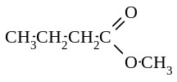

12.67. What acid and alcohol, respectively, can be used to prepare the ester shown: ?

A CH₃CH₂CH₂COOH and CH₃OH B CH₃CH₂COOH and CH₃CH₂OH
C CH₃COOH and CH₃CH₂CH₂OH D HCOOH and CH₃CH₂CH₂CH₂OH
E CH₃OCOOH and CH₃CH₂CH₂OH

12.68 Which of the following is an ester?
A | 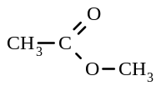 | B | 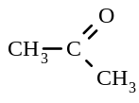 | C | 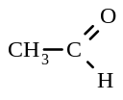
D | 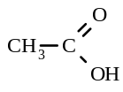 | E | 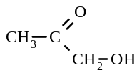

12.69. Which of the following statements concerning detergents is correct?
A They do not lather in hard water
B They are soluble in water because their molecules have a hydrophilic group
C They are made by the saponification of vegetable oils
D They contain a long hydrocarbon chain which attracts water molecules

12.70. Which of the following substances would produce a ketone when oxidised with acidified potassium permanganate
solution?
A Ethanol B Acetic acid (ethanoic acid) C Propan-1-ol
D Propan-2-ol E 2-Methylpropan-2-ol

12.71. Which of the following substances is least likely to dissolve in (or be miscible with ) water?
A HCOOH B CH₃NH₂ C CH₃CH₂OH
D CH₃COONa E CH₃CH₂CH₃

12.72. Which of the following combinations of reactants will produce a soap?
A An alcohol plus a fatty acid B Sodium hydroxide plus an alcohol
C A fatty acid plus sodium hydroxide D A sodium salt plus glycerol
E An alkene plus a halogen

12.73. Which of the following combinations of reactants can be used to make a condensation polymer?
A CH₃(CH₂)₄COOH and HOCH₂(CH₂)₄CH₃
B CH₂OH(CH₂)₄CH₂OH and HOOC(CH₂)₄COOH
C CH₂OH(CH₂)CH₂OH and CH₃COOCH₂(CH₂)₄CH₂OCOCH₃
D CH₂=CH₂ and CH₂=CHCl
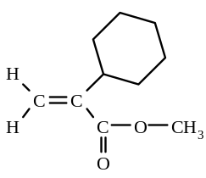
E CH₃(CH₂)₄CH₂OH and HOOC(CH₂)₄COOH

12.74. Substance ‘A’ has the following structure:

Which of the following statements is NOT true about substance ‘A’?
A It is a ketone B It is an unsaturated compound
C It is an aromatic compound D It is an ester of methanol
E Its empirical formula is C₅H₅O.

12.75. Which of the following pure substances will exhibit hydrogen bonding between neighbouring molecules?
A Propane B Propan-1-ol C Propene D Propanal E Propanone

12.76. Which of the following would you expect to be produced when butan-2-ol is oxidised with dilute aqueous
potassium permanganate solution?
A | 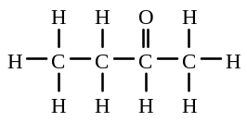 | B | 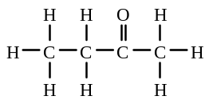 | C | 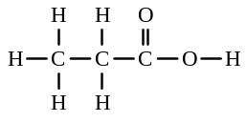
D | 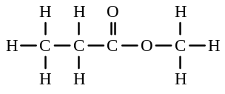 | E | H - O - H and O = C = O

12.77. A nail varnish remover was found to be immiscible with water. It also had no reaction with an acidified solution
of potassium permanganate. Which of the following could the nail varnish remover be?
A ethanol B ethanoic acid C ethyl ethanoate
D sodium ethanoate E ethanal

12.78. When excess sodium hydroxide is added to ethyl propanoate and heated under reflux for some time, the major
products formed are
A ethanol and propanoic acid B ethanol and sodium propanaote
C propan-1-ol and ethanoic acid D propan-1-ol and sodium ethanoate

12.79. Which of the following formulae best represents a soap?
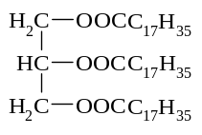
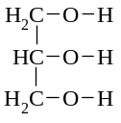
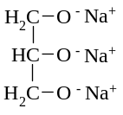
A B C

D C₁₇H₃₅COO⁻ Na⁺ E C₁₇H₃₅COOH

12.80. If methyl ethanoate is boiled with an excess of aqueous sodium hydroxide and the resulting solution is then
distilled, the distillate contains mainly
A methanol B ethanoic acid C methanoic acid
D ethanol E sodium ethanoate

12.81. Oil molecules are non-polar, consequently oil slicks on the ocean
A dissolve readily in water B sink to the bottom of the ocean
C dissolve in highly polar organic solvents D are essentially insoluble in water.
⎯ O - C - (CH₂)₃ - C - O - CH₂ - CH₂ ⎯

n
O
O
12.82. The monomers from which this polymer was made are

A HOCH₂ - (CH₂)₃ - CH₂OH and HOOC - COOH
B HOOC - (CH₂)₃ - COOH and HOCH₂ - (CH₂)₂ - CH₂OH
C HOOC - (CH₂)₃ - COOH and HO - (CH₂)₂ - OH
D HOOC - (CH₂)₃ - CH₂OH and HO - CH₂ - COOH
E HOOC - (CH₂)₃ - CHO and HO - CH₂ - CH₃

12.83. The formation of soap from a fat is an example of
A an addition reaction B a substitution reaction C esterification
D condensation E saponification

12.84. In which one of the following pairs of substances will hydrogen bonding NOT occur between the two substances?
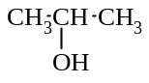
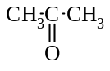
A CH₃COOH and B CH₃NH₂ and

C HF and CH₃CH₂OCH₂CH₃ D CH₃CH₃ and CH₃CH₂OH
E NH₃ and CH₃NH₂

12.85 Which one of the following statements is false?
A Oxidation of butan-1-ol with acidified potassium permanganate solution produces butanal and, subsequently, butanoic acid.
B Oxidation of butan-2-ol with acidified potassium permanganate solution produces butan-2-one.
C But-2-ene when treated with bromine produced 2,3-dibromobutane
D Methane when treated with hydrogen chloride produces chloromethane and hydrogen gas.
E Ethanol reacts with sodium to form sodium ethoxide and hydrogen gas.
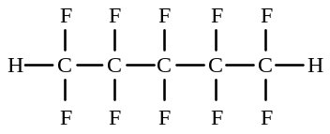

12.86 The polymer Teflon has the following structure

The monomer for Teflon is
A CF₃CF₃ B CHF₂CHF₂ C CHF=CHF D CF₄ E CF₂=CF₂

12.87. Which statement is FALSE concerning the compound with the structure
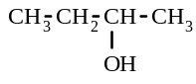

A It can be oxidised by dichromate ion, forming a ketone. B It can participate in hydrogen bonding.
C It reacts with sodium metal producing hydrogen gas. D It is a secondary alcohol.
E It can be converted to an ester by reaction with an aldehyde.

12.88. Which of the following compounds cannot be used as a raw material for preparing a condensation polymer?
A HOCH₂CH₂OH B HOOC(CH₂)₄COOH C HOCH₂CH₂COOH
D CH₃CH(OH)C₆H₄CH₂OH E CH₃C₆H₄COOH

12.89. After boiling a fat or oil with dilute sodium hydroxide solution to prepare a soap, the mixture is again boiled with a concentrated solution of common salt.
The purpose of the salt is to
A give a better equilibrium mixture on hydrolysis B convert the fatty acid to a sodium salt
C precipitate the soap from the solution D catalyse the hydrolysis of the fat or oil
E purify the soap

12.90. A student determined the following properties of an organic compound, Z:
I Z contains the elements carbon, hydrogen and oxygen
II Z is neutral to litmus
III On reaction with acidified potassium permanganate, the product W turned litmus red.
The compound Z could be
A propane B propan-2-ol C propan-1-ol D propanoic acid

Miscellaneous short answer & calculation problems

12.91. Give the I.U.P.A.C. name for each of the following compounds
a) | 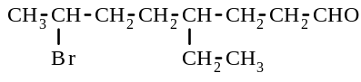 | b) | 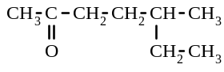
c) | 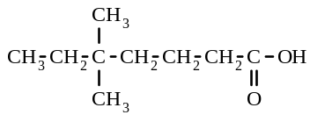 | d) | 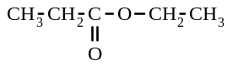
e) | 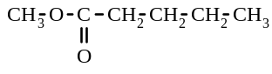 | f) | 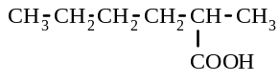
g) | CH₃ CH₂ CH₂ CH₂ CO₂ CH₂ CH₂ CH₃ | h) | 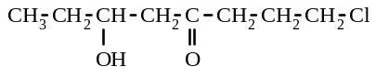
i) | CH₃ O OC CH₃ | j) | H₂N CH₂ CH₂ CH₂ CHO
k) | 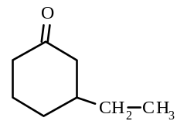 | l) | 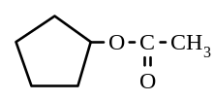
m) | 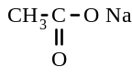 | n) | Mg ( CH₃CH₂COO)₂

12.92. Draw the structural formulae for the following:
a) pentanoic acid b) 3-chloropropanal c) 2-methylhexan-3-one
d) potassium ethanoate e) methyl propanoate f) 1-propyl methanoate
g) 3-aminobutanoic acid h) propane-1,3-diol i) 1,2-dichloroethene
j) 1-butyl ethanoate
12.93. Give the structural formula for each of the organic products formed in the following reactions:
a) the esterification of methanol and ethanoic acid b) the oxidation of 2-propanol
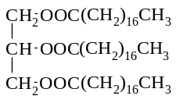
c) the oxidation of 2-methyl-2-propanol d) the saponification of

e) the polymerisation of propene
f) the condensation polymerisation of HOOC - (CH₂)₄ - COOH and HO - (CH₂)₃ - OH
g) the hydrolysis (in the presence of concentrated sulfuric acid) of 1-propyl butanoate

12.94. Fill in the gaps:
Soap as a cleaning agent
A soap is often described as a s..................................... . Its function is to assist water to remove g.............................. , o.................... , d................... and other water-i............................ materials that adhere to surfaces.
To understand the cleaning process, the nature of the surfactant needs to be examined. The surfactant is a large ion consisting of a n................................ charged end and an uncharged, n.............-p......................... end. Polar or charged particles tend to dissolve in p.......................... solvents, whereas non-polar substances tend to dissolve in n.................................. solvents. Water is a p.................... solvent which can form h.......................... b................. with the c.......................... end of the surfactant. This c........................ end is known as the h........................... or "water-loving" end of the surfactant. As a result, this end of the surfactant ion tends to d.............................. readily in water.
On the other hand, the other n........- p..................... end tends not to dissolve in water. However, this h.................................. or "water-hating" end of the ion can readily mix with n...........- p...................... dirt, g........................ or o............... Hence the n..........- p...................... hydrocarbon end of the surfactant attaches to the n.........- p...................... grease or oil while the charged end is h.......................... b........................ to the water molecules.
When the water is agitated, the o............... and g....................... are removed from the surface being cleaned because they are attached by d................................ forces to the h................................. end of the surfactant ion. The grease tends to be surrounded by spherical aggregates of s............................. i.............. whose polar "heads" are directed towards the w...................... and the non-polar "tails" are attached to the g.....................

12.95. Write a balanced equation, using structural formulae, for each of the following reactions:
a) the reaction of propan-1-ol with an acidified solution of potassium permanganate, to form propanoic acid
b) the oxidation of butan-2-ol with an acidified solution of sodium dichromate.
c) the reaction of a solution of potassium hydroxide with ethanoic acid
d) the reaction of ethyl propanoate with hot sodium hydroxide solution
e) the reaction of methanol with ethanoic acid, in the presence of concentrated H₂SO₄.

12.96. Give the formulae and names of the addition polymers formed from the following compounds:
a) bromoethene b) tetrafluoroethene c) CH₃CH=CHCH₃

12.97. Give an equation, showing structural formulae, for the condensation polymerisation reaction that occurs for each
of the following monomers:
a) 1,4-dibenzoic acid and ethane-1,2-diol b) HO - (CH₂)₄ - COOH

12.98. Give the structural formulae of the monomers used in the preparation of the following polymers:
a) b)
( CH₂ - CH₂ ) n
( OC - (CH₂)₆ - COO - (CH₂)₃ - O ) n
( CH₂ - CH ) n
Cl
( O - (CH₂)₂ - OOC - - COO ) n
c) d)

( CH₂ - CHCl ) n
e)

12.99. a) An unknown hydrocarbon was found by analysis to consist of 85.7% carbon and 14.3% hydrogen.
Calculate the empirical formula.
b) A 2.80 g sample of the hydrocarbon, in the gaseous state, occupied 1.18 L at 25ºC and 105 kPa pressure.
Calculate the relative molecular mass and the molecular formula.
c) Draw three possible structural formulae for the unknown hydrocarbon.
d) When treated with bromine, the unknown hydrocarbon formed a 2,3-dibromo hydrocarbon substituted product. What is the actual structural formula.

12.100. a) 3.45 g of an organic compound containing carbon, hydrogen and oxygen was burnt in oxygen to yield 6.60 g
of carbon dioxide and 4.05 g of water. Calculate the empirical formula of the compound.
b) When 1.38 g of the compound was heated to 100.0oC, it was gaseous and occupied a volume of 0.950 L at a pressure of 98.0 kPa. Calculate the relative molecular mass and the molecular formula of the organic
compound.
c) Write possible structural formulae for the unknown compound. The unknown compound does react with sodium. What is its actual structural formula?

12.101 0.682 g of a compound containing carbon, hydrogen and oxygen produced 0.968 g of carbon dioxide and 0.594 g of water, when burnt in oxygen. A further 0.744 g sample of the compound, when vaporised, occupied 497 mL at 200ºC and 95.0 kPa. The unknown that the compound did not contain a carbonyl group.
Determine:
a) the empirical formula
b) the relative molecular mass and the molecular formula
c) two possible structural formulae.

12.102. 1.180 g of an organic compound produced, on combustion, 2.64 g of carbon dioxide and 1.62 g of water. When 1.180 g of the same compound was decomposed, it released 0.472 L of nitrogen gas measured as 25ºC and
105 kPa pressure. Another sample of the gas as 19ºC and 95.5 kPa pressure was found to have a volume of
0.254 L and a mass of 0.5896 g.
Determine:
a) the empirical formula
b) the relative molecular mass and molecular formula, and
c) a structural formula of the compound

12.103. An unknown compound consists of carbon, hydrogen and chlorine. 1.324 g of the compound is divided into two equal samples. The first sample, when burnt in oxygen, produced 1.189 g of carbon dioxide. The second sample was oxidised with concentrated nitric acid and treated with silver nitrate to yield 1.292 g of silver chloride.
The relative molecular mass of the unknown was found from freezing point depression measurements to be 147.
Determine:
a) the empirical formula
b) the molecular formula, and
c) given that the compound is derived from benzene, draw three possible structural formulae for the compound.

12.104. A 0.666 g of a sample of an unknown organic compound (containing carbon, hydrogen and oxygen) when burnt in oxygen produced 1.584 g of carbon dioxide and 0.810 g of water. The unknown, in gaseous state, had a density of 1.91 g L⁻¹ at 200ºC and 101.3 kPa pressure.
Determine:
a) the empirical formula
b) the molecular formula, and
c) three possible structural formulae.
d) The compound reacts slowly with sodium, but is not oxidised by acidic potassium permanganate. Write the structural formula of the compound.

12.105. Give the systematic names and the structural formulae for two carboxylic acids and two esters with the
formula C₄H₈O₂.

12.106. Give the systematic names and the structural formula for one aldehyde and one ketone with the formula C₄H₈O.

12.107. a) Identify each of the following as a primary alcohol, secondary alcohol, tertiary alcohol, aldehyde, ketone,
carboxylic acid or ester:
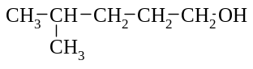
i) CH₃ - CH₂ - CH₂ - COOH ii) CH₃ - CH₂ - CO - CH₃ iii)

iv) | propan-2-ol | v) | 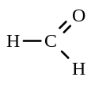 | vi) | 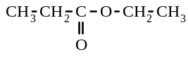
vii) 2-methylpentan-3-ol viii) ethylpentan-3-ol

b) i) After dichromate oxidation, an organic compound with a molecular formula of C₅H₁₂O forms pentanoic acid. Give the IUPAC name and the structural formula of the organic compound:

ii) After dichromate oxidation, an organic compound with a molecular formula of C₅H₁₂O forms methylbutanone. Give the IUPAC name and the structural formula of the organic compound:

12.108. The two steps involved in the manufacture of P.V.C. (polyvinyl chloride) from ethyne and hydrogen chloride are:
Step 1: Hydrogen chloride is reacted with ethyne, to form chloroethene.
Step 2: In the presence of a catalyst, heat and pressure, chloroethene reacts to form polyvinyl chloride.
a) Give an equation for the formation of chloroethene from the reaction of ethyne with hydrogen chloride.
b) What type of reaction is this?
c) Give an equation for the reaction in Step 2.
d) What type of reaction is this?

12.109. Draw an electron dot diagram of each of the following molecules so that all valence electron pairs are clearly
indicated.
a) CH₂Cl₂ b) C₂H₄ c) methanal, H₂CO
d) an alkene with the molecular formula C₂H₃Cl.

12.110. For each of the products shown below, choose from the following list TWO materials used DIRECTLY in its commercial production.
Materials: air, ammonium nitrate, animal fat, coke, cryolite, hydrogen, nitric acid, nitrogen, oxygen,
paraffin wax, bauxite, soda ash, sodium chloride, sodium hydroxide, sulfur, vanadium pentoxide
a) sulfuric acid b) ammonia c) soap d) aluminium

12.111. Complete the following table:
IUPAC name | Structural formula
a) 2-chlorohexan-1-ol
b) methyl propanoate
c) | CH₃ - CH₂ - CH = CH₂
d) | CH₃ - CH₂ - CH₂ - CO - CH₃

12.112. Write the structural formula of ONE organic product of each of the following.
a) Bromine is added to propene.
b) Ethanal is treated with acidified potassium permanganate solution.
c) Ethane is mixed with a large excess of chlorine and exposed to light.
d) Methyl ethanoate is boiled with sodium hydroxide solution.

12.113. The structural formula for propan-1-ol is shown on the right: CH₃ - CH₂ - CH₂ - OH
a) Drawing the structural formulae for isomers of propan-1-ol which are i) an alcohol ii) not an alcohol
b) When propan-1-ol is reacted with acidified KMnO₄ solution, it forms a volatile liquid, A, which is itself readily
oxidised by the permanganate to form an oily liquid, B, with a sharp unpleasant odour. Give the structural
formulae, and name, for the species A and B.
12.114 Give the structural formulae and name the organic products formed in each of the following reactions:
a) when propan-2-ol is oxidised by acidified K₂Cr₂O₇ solution.
b) when propene reacts with bromine
c) when propanoic acid reacts with ethanol on the presence of H⁺(aq).

12.115. Complete the following table for isomers of C₄H₈O₂:
a) In (1) and (2) give the IUPAC names for the pair of isomers given.
b) In (3) give the structural formula of the named third isomer.
c) In (4) give the structural formula and name of a fourth isomer.

(1)  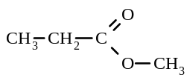  Name: | (2)  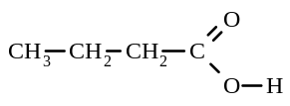  Name:
(3)  Structural  formula:  Name: ethyl ethanoate | (4)  Structural  formula:  Name:

12.116. Give the structural formulae of the following compounds:
a) 2-bromo-2-methylpropane b) methyl ethanoate c) trans but-2-ene

12.117. Using half equations, write a balanced equation for the oxidation of ethanol to ethanoic acid with acidified potassium dichromate solution.

12.118. Give the I.U.P.A.C. names of the following compounds: a) CH₃.CHOH.CH₃ b) CH₃.CH₂.CO.CH₃

12.119. Write balanced equations for the following reactions:
a) the reaction between ethanol and butanoic acid (acid catalysed)
b) the addition of hydrogen chloride to ethene

12.120. Two substances are named below. Name a third substance which could be used to distinguish between them. State what would be observed.
propan-2-ol and 2-methylpropan-2-ol

12.121. An unknown organic compound is known to be a simple ester. Its molecular weight is found to be 60.
a) Draw a structural formula for the compound.
b) Give an I.U.P.A.C. name for the compound.
c) What is an I.U.P.A.C. name for a carboxylic acid isomeric with the unknown compound?

12.122. Derive a balanced chemical equation for the following reaction, showing the oxidation half equation, the reduction half equation and the final overall equation:
propanal is oxidised to propanoic acid by acidified potassium dichromate solution.
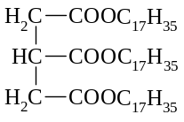
12.123. A Year 12 exam paper erroneously gave the formula of glyceryl tristearate (a fat) as

a) Give the correct structural formula of glyceryl tristearate (stearic acid is C₁₇H₃₅COOH).
b) Give the structural formulae for the products of the hydrolysis of glyceryl tristearate with sodium hydroxide solution.

12.124. Give an example of each of the following. Indicate your example by a structural formula.
a) An alkyl group b) A branched chain carboxylic acid with 6 carbon atoms
c) An aldehyde with 6 hydrogen atoms d) A tertiary alcohol
e) An aromatic amine f) An ester which an isomer of butanoic acid

12.125 The substance X has the structure
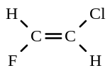

a) Give the I.U.P.A.C. name for the substance X.
b) Give the structural formula (showing all the hydrogen atoms) of Y, a geometrical isomer of X.
c) Give the structural formula (showing all the hydrogen atoms) of Z, a structural isomer of X.
d) X can undergo addition polymerisation. Draw part of the structure of this polymer showing at least six carbon atoms.

e) Y and Z can each undergo addition polymerisation. One of these polymers has a different structure to that formed by X. Draw this polymer showing at least six carbon atoms.

12.126. A compound of carbon, hydrogen, nitrogen and oxygen was analysed as follows.
First, a sample (1.342 g) was burned in excess oxygen and the resultant water and carbon dioxide absorbed in separate traps and weighed. The mass of water was 0.288 g and that of the carbon dioxide was 2.109 g.
A second sample (1.061 g) was treated to convert all the nitrogen into ammonia which was then analysed by
titration and found to be 1.263 x 10⁻² mol.
Calculate the empirical formula of the compound.

12.127. a) An unknown gaseous compound contains only carbon, oxygen and chlorine. the compound hydrolyses in water to produce only carbon dioxide and hydrogen chloride. When 2.20 g of the compound was hydrolysed, 0.970 g of CO₂ was produced and the hydrogen chloride formed required 42.8 mL of 1.04 mol L⁻¹ NaOH solution for complete neutralisation. Calculate the empirical formula of the compound.

b) A further 3.31 g sample of the gaseous compound occupied 0.750 L at 0ºC and 101.3 kPa pressure. Calculate
the molecular weight of the compound and hence its molecular formula.
c) Write a possible structural formula for the compound, showing all the bonds present in the unknown compound.

12.128. An organic compound consisting of carbon, hydrogen and oxygen was analysed by combustion. Complete combustion of 0.290 g of the compound gave 0.660 g of carbon dioxide and 0.270 g of water. Equal volumes of oxygen and the vaporised compound under the same conditions of temperature and pressure weighed 1.00 g and
1.81 g respectively.
a) Calculate the empirical formula of the compound.
b) Calculate the molecular weight and the molecular formula of the compound.
c) Draw three possible structural formulae for this compound.

12.129. An unknown organic compound X contains only the elements carbon, hydrogen and oxygen.
When 1.360 g of X is completely burned in an excess of oxygen the products are found to be 1.113 g of water and 1.384 L of carbon dioxide measured at a temperature of 273 K and a pressure of 101.3 kPa.
When a further 2.500 g sample of X is vaporised, the volume of the vapour produced is found to be 868.9 mL
when measured at a temperature of 373 K and a pressure of 101.3 kPa.
a) Determine the empirical formula of X
b) Determine the molecular formula of X.
c) Given that X will react with a solution of sodium carbonate to produce carbon dioxide, draw and name two possible structures for X.

12.130. Substance X, containing the elements C, H and O only, may be converted to a monoprotic acid Y by the action of an excess of dilute aqueous acidified potassium permanganate. 18.70 mL of a solution of 1.0165 g L⁻¹ of Y was required to neutralise 20.00 mL of 0.0108 mol L⁻¹ potassium hydroxide.
Substance Z may be prepared by heating X with an excess of ethanoic acid in the presence of a small amount of concentrated sulfuric acid, followed by purification of the product. When 0.2870 g of Z was completely burned in
an excess of oxygen the products were 0.6532 g of carbon dioxide and 0.2672 g of water.
a) Calculate the molecular weight of Y
b) Calculate the empirical formula of Z
c) Given that the carbon chain of X is branched, draw the structural formula for X, Y and Z which are consistent with the data.

ANSWERS - Organic Chemistry - 2

12.1. a) alcohol, 5-methylheptan-3-ol b) aldehyde, 3-ethylpentanal
c) aldehyde. 2,4,4,5-tetramethylhexanal d) carboxylic acid, 2-bromobutanoic acid
e) carboxylic acid, octanoic acid f) carboxylic acid, 2-ethylpentanoic acid
g) ketone, octan-2-one h) ketone, 1-chloro-4-methylpentan-2-one

12.2. | a) | 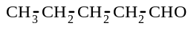 | b) | 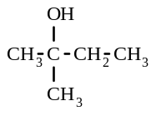 | c) | 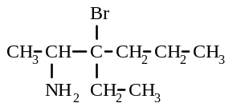
 | d) | 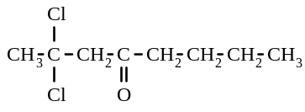 | e) | 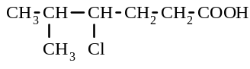

12.3. a) propanal CH₃ - CH₂ - CHO b) pentanoic acid CH₃ - CH₂ - CH₂ - CH₂ - COOH
c) hexan-3-one CH₃ - CH₂ - CO - CH₂ - CH₂ - CH₃ d) no reaction
e) methylpropanoic acid f) pentan-3-one CH₃ - CH₂ - CO - CH₂ - CH₃
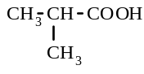

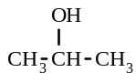
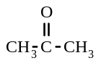
12.4. a)
→ + 2H⁺ + 2e x 5
MnO₄⁻ + 8H⁺ + 5e → Mn²⁺ + 4H₂O x 2

5 + 2MnO₄⁻ + 6H⁺ → 5 + 2 Mn²⁺ + 8 H₂O

b) CH₃ CH₂ CH₂ CH₂ OH → CH₃ CH₂ CH₂ CHO + 2H⁺ + 2e x 3
Cr₂O₇²⁻ + 14H⁺ + 6e → 2Cr³⁺ + 7 H₂O

3 CH₃ CH₂ CH₂ CH₂ OH + Cr₂O₇²⁻ + 8H⁺ → 3 CH₃ CH₂ CH₂ CHO + 2Cr³⁺ + 7 H₂O

c) CH₃ CH₂ CH₂ CH₂ CHO + H₂O → CH₃ CH₂ CH₂ CH₂ COOH + 2H⁺ + 2e x 5
MnO₄⁻ + 8H⁺ + 5e → Mn²⁺ + 4H₂O x 2

5 CH₃ CH₂ CH₂ CH₂CHO + 2MnO₄⁻ + 6H⁺ → 5 CH₃ CH₂ CH₂ CH₂COOH + 2 Mn²⁺ + 3 H₂O
d) no reaction
e) CH₃ CH₂ CH₂OH + H₂O → CH₃ CH₂ COOH + 4H⁺ + 4e x 3
Cr₂O₇²⁻ + 14H⁺ + 6e → 2Cr³⁺ + 7 H₂O x 2

3 CH₃ CH₂ CH₂OH + 2 Cr₂O₇²⁻ + 16H⁺ → 3 CH₃ CH₂ COOH + 4Cr³⁺ + 11 H₂O

12.5. a) CH₃ - CO - O - CH₂ - CH₂ - CH₃ 1-propyl ethanoate
b) CH₃ - CH₂ - CH₃ - CO - O - CH₂ CH₃ ethyl butanoate
c) CH₃ - CH₂ - CH₂ - CO - O - CH₃ methyl butanoate

12.6. a) ethyl pentanoate b) 1-propyl propanoate c) ethyl butanoate d) 1-propyl methanoate

12.7. a) CH₃ - CO - O - CH₂ - CH₂ - CH₃ b) CH₃ CH₂ CH₂ CH₂ CH₂ CO - O - CH₂ CH₃

12.8. a) CH₃ COOH + CH₃OH b) CH₃ - CH₂ - CH₂ - COO⁻ Na⁺ + CH₃ - CH₂ - CH₂OH
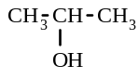
12.9. a) CH₃ - CH₂ - CH₂ OH CH₃ - O - CH₂ - CH₃
propan-1-ol (an ether)
propan-2-ol

12.9 b) CH₃ - CH₂ - CHO CH₃ - CO - CH₃
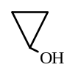
propanal propanone cyclopropanol
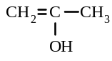
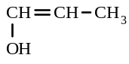
CH₂ = CH - CH₂ OH

1-hydroxyprop-2-ene
2-hydroxyprop-1-ene 1-hydroxyprop-1-ene

c) CH₃ - CH₂ - COOH CH₃ - CO - O - CH₃ HCO - O - CH₂ - CH₃
propanoic acid methyl ethanoate ethyl methanoate
Also, a series of compounds with - one double bond and two alcohol groups
- a three membered ring and two alcohol groups
- one alcohol group and an aldehyde or ketone group

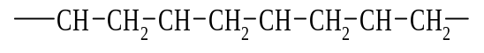
12.10. a) - CCl₂ - CCl₂ - CCl₂ - CCl₂ - CCl₂ - CCl₂ -
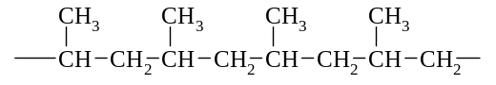
b) c)

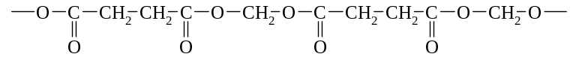
12.11. a)

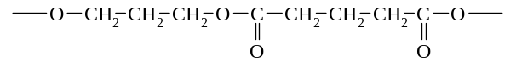
b)

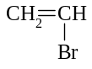
12.12 a) b)

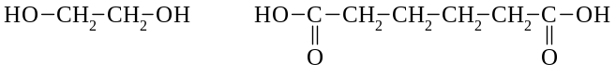
c)

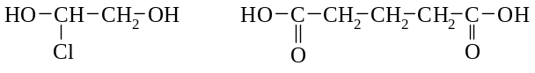
d)

12.13. a) glycerol b) detergent c) fat d) soap e) fatty acid

12.14 a) C₆H₆ b) (benzene)

12.15. a) C₆H₇N b) C₆H₇N c) NH₂

12.16. C₃H₃O

12.17. A 12.18. E 12.19. D
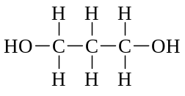
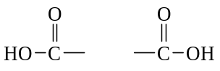

12.20.

12.21 a) moles of CO₂ = 1.078/44.01 = 0.02449 = moles of C in ‘A’
moles of H₂O = 0.441/18.016 = 0.02448 so, moles of H in ‘A’ = 2 x 0.02448 = 0.0490
mass of C present = 0.02449 x 12.01 = 0.2941 g
mass of H present = 1.008 x 0.0490 = 0.04939 g
mass of O present = 0.6047 - (0.2941 + 0.04939) = 0.2612 g
mole of O present in ‘A’ = 0.2612/16.0 = 0.01632
moles ratio = C : H : O = 0.02449 : 0.0490 : 0.01632 = 1.50 : 3.00 : 1 = 3 : 6 : 2
i.e. the empirical formula is C₃H₆O₂
b) PV = nRT n = = 0.001862
molar mass = 0.1367/0.001863 = 73.38 g mol⁻¹ i.e. molecular weight = 73.4
c) molecular formula = n x empirical formula i.e. n = 73.4/74 ≈ 1
so molecular formula = C₃H₆O₂
12.21 cont d)
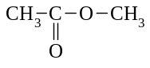

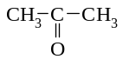
12.22. a ketone: propanone an aldehyde: propanal
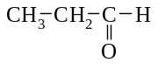

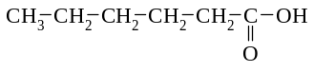
a carboxylic acid: hexanoic acid

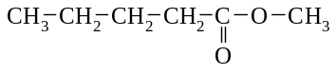
an ester: methyl pentanoate

12.23.
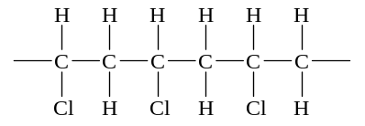

12.24 moles of CO₂ = 1.110/44.01 = 0.02522 = moles of C in ‘A’
moles of H₂O = 0.303/18.016 = 0.01682 so, moles of H in ‘A’ = 2 x 0.01682 = 0.03364
mass of C present = 0.02522 x 12.01 = 0.3029 g mass of H present = 1.008 x 0.03364 = 0.03391 g
mass of O present = 0.8062 - (0.3029 + 0.03391) = 0.4694 g
mole of O present in ‘A’ = 0.4695/16.0 = 0.02934
moles ratio = C : H : O = 0.02522 : 0.03364 : 0.02934 = 1 : 1.33 : 1.16 = 6 : 7.98 : 6.983
≈ 6 : 8 : 7
i.e. the empirical formula is C₆H₈O₇

12.25. B 12.26. E

12.27. a) CH₃COOH + CH₃OH → CH₃COOCH₃ + H₂O - sweet smelling odour produced, mixture remains colourless
b) CH₃COO⁻(aq) + H⁺(aq) → CH₃COOH(aq) - solution remains colourless, vinegar-smelling odour produced.

12.28. a) sulfuric acid b) oxalic acid c) benzoic acid d) tetrahydroxozincate ion
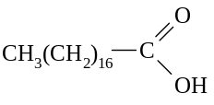
12.29.

12.30. Oxidation half-equation CH₃CHOHCH₃ → CH₃COCH₃ + 2H⁺ + 2e
Reduction half-equation Cr₂O₇²⁻ + 14H⁺ + 6e → 2Cr³⁺ + 7H₂O
Redox equation Cr₂O₇²⁻ + 8H⁺ + 3CH₃CHOHCH₃ → 2Cr³⁺ + 7H₂O + 3CH₃COCH₃

12.31.
 | Your chemical test. Describe fully | What you would observe in each case
Cu(NO₃)₂ | Dissolve both in water, add a solution of barium | with Cu(NO₃)₂ - no precipitate forms
and  CuSO₄ | nitrate to each | with CuSO₄ - precipitate forms
MgCl₂ | Dissolve both in water, then slowly add a solution | with MgCl₂ - a white precipitate forms
and  ZnCl₂ | of sodium hydroxide to each | with ZnCl₂ - a white precipitate forms, but it then dissolves when excess NaOH is added.
CH₃CH₂OH | Test both with moist blue litmus paper | with CH₃CH₂OH - litmus not affected
and  CH₃COOH |  | with CH₃COOH - litmus turns red

12.32. Oxidation half-equation CH₃CHO + H₂O → CH₃COOH + 2H⁺ + 2e
Reduction half-equation Cr₂O₇²⁻ + 14H⁺ + 6e → 2Cr³⁺ + 7H₂O
Redox equation Cr₂O₇²⁻ + 8H⁺ + 3CH₃CHO → 2Cr³⁺ + 4H₂O + 3CH₃COOH
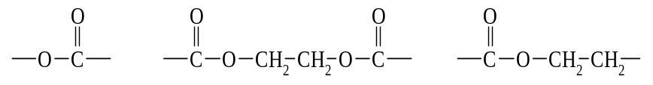
12.33.

12.34. a) 4-methylhexanal b) ethyl propanoate c) butanal d) 1-propyl methanoate
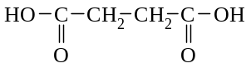
12.35. a) HO - CH₂ - CH₂ - OH b) condensation c) H₂O

12.36. a) C : H = 90.49/12.01 : 9.48/1.008 = 7.53 : 9.40 = 1 : 1.25 = 4 : 5
i.e. the empirical formula is C₄H₅
b) Hydrocarbons have an even number of hydrogens (or there would be an uneven number of electrons in this molecule)

. c) molecular formula = n x empirical formula i.e. n = 105/53 ≈ 2
so molecular formula = C₈H₁₀

d)
CH₂CH₃
CH₃
CH₃
CH₃
CH₃
CH₃
CH₃

12.37. B 12.38. C 12.39. E 12.40. A 12.41. D

12.42. a) i) B ii) A iii) C
b) i) detergents
ii) When a detergent is added to washing water, the detergent ions (surfactant molecules) surround the grease and oil with the non-polar "tails" attached to the grease, and the polar ends left exposed to the water. With agitation, small grease blobs surrounded by detergent ions are produced. These blobs are able to mix, and possibly dissolve in the water because they act as polar substances (due to the polar ends of the ions projecting from them). Thus, the grease can be rinsed away.
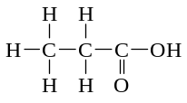

12.43. a) It is a carboxylic acid containing 3 C atoms i.e. name: propanoic acid

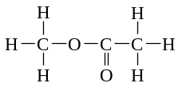

b) name: methyl ethanoate

12.44. Substance A: ethyl ethanoate Substance B: sodium ethanoate
Substance C: ethanol Substance D: ethanoic acid
12.45 D 12.46 A 12.47 D 12.48 C 12.49 A
12.50 B 12.51 A 12.52 A 12.53 A 12.54 D
12.55 D 12.56 C 12.57 A 12.58 D 12.59 A
12.60 B 12.61 C 12.62 D 12.63 D 12.64 E
12.65 D 12.66 D 12.67 A 12.68 A 12.69 B
12.70 D 12.71 E 12.72 C 12.73 B 12.74 A
12.75 B 12.76 B 12.77 C 12.78 B 12.79 D
12.80 A 12.81 D 12.82 C 12.83 E 12.84 D
12.85 D 12.86 E 12.87 E 12.88 E 12.89 C
12.90 C
12.91. a) 7-bromo-4-ethyloctanal b) 5-methylheptan-2-one c) 5,5-dimethylheptanoic acid d) ethyl propanoate e) methyl pentanoate f) 2-methylhexanoic acid
g) propyl pentanoate h) 1-chloro-6-hydroxyoctan-4-one i) methyl ethanoate
j) 4-aminobutanal k) 3-ethylcyclohexanone l) cyclopentyl ethanoate
m) sodium ethanoate n) magnesium propanoate
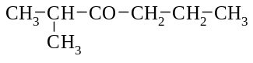
12.92. a) CH₃ - CH₂ - CH₂ - CH₂ - CO OH b) ClCH₂ - CH₂ - CHO c)

d) CH₃ - CO - O⁻ K⁺ or KCH₃COO e) CH₃ - CH₂ - CO - O - CH₃ f) H - CO - O - CH₂ - CH₂ - CH₃

12.92 cont g) h) HO CH₂ - CH₂ - CH₂ OH i) Cl CH = CH Cl
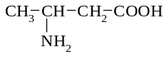

j) CH₃ - CO - O - CH₂ - CH₂ - CH₂ - CH₃

12.93. a) CH₃ - CO - O - CH₃ b) CH₃ - CO - CH₃
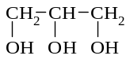
c) a tertiary alcohol cannot be oxidised d) + CH₃ (CH₂)₁₆ COO⁻ (+ Na⁺ or K⁺)

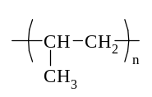
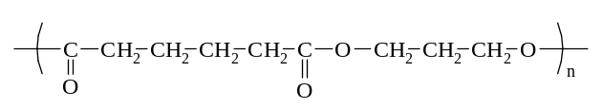

e) f)

g) CH₃ - CH₂ - CH₂ OH + CH₃ - CH₂ - CH₂ - COOH

12.94. Soap as a cleaning agent
A soap is often described as a surfactant. Its function is to assist water to remove grease , oil , dirt and other water-insoluble materials that adhere to surfaces.
To understand the cleaning process, the nature of the surfactant needs to be examined. The surfactant is a large ion consisting of a negatively charged end and an uncharged, non -polar end. Polar or charged particles tend to dissolve in polar solvents, whereas non-polar substances tend to dissolve in non-polar solvents. Water is a polar solvent which can form hydrogen bonds with the charged end of the surfactant. This charged end is known as the hydrophilic or "water-loving" end of the surfactant. As a result, this end of the surfactant ion tends to dissolve readily in water.
On the other hand, the other non- polar end tends not to dissolve in water. However, this hydrophobic or "water-hating" end of the ion can readily mix with non - polar dirt, grease or oil Hence the non- polar hydrocarbon end of the surfactant attaches to the non- polar grease or oil while the charged end is hydrogen bonded to the water molecules.
When the water is agitated, the oil and grease are removed from the surface being cleaned because they are attached by dispersion forces to the hydrophobic end of the surfactant ion. The grease tends to be surrounded by spherical aggregates of surfactant ions whose polar "heads" are directed towards the water and the non- polar "tails" are attached to the grease.

12.95. a) 5 CH₃ CH₂ CH₂ OH + 4MnO₄⁻ + 12 H⁺ → 5 CH₃ CH₂ COOH + 4Mn²⁺ + 11H₂O
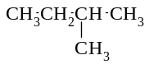
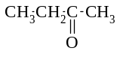
b) 3 + 8H⁺ + Cr₂O₇²⁻ → 3 + 2Cr³⁺ + 7H₂O

c) CH₃ COOH + OH ⁻ → CH₃ COO ⁻ + H₂O
d) CH₃ CH₂ OOC CH₂ CH₃ + OH⁻ → CH₃ CH₂ OH + CH₃ CH₂ COO⁻
e) CH₃ OH + CH₃ COOH → CH₃ OOC CH₃ + H₂O
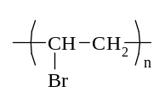
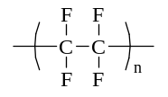
12.96. a) poly(bromoethene) b) poly(tetrafluoroethene)

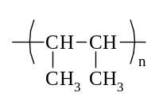

c) poly(but-2-ene)

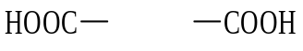
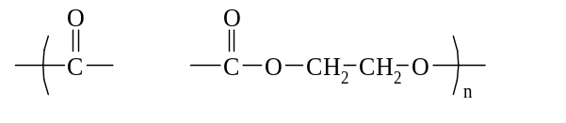
12.97. a) n + n HO CH₂ CH₂ OH

+ n H₂O

b) n HO - (CH₂)₄ - COOH + n HO - (CH₂)₄ - COOH ( O - (CH₂)₄ - CO - O - (CH₂)₄ - CO )_{n} + n H2O

12.98. a) CH₂ = CH₂ b) HOOC - (CH₂)₆ - COOH + HO - (CH₂)₃ - OH

c) CH₂ = CH - d) HOOC - - COOH + HO - (CH₂)₂ - OH

Cl
e) CH₂ = CH Cl

12.99. a) CH₂ b) 56, C₄H₈
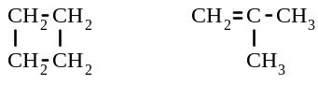
c) CH₂ = CH - CH₂ - CH₃ CH₃ - CH = CH - CH₃

d) CH₃ - CH = CH - CH₃

12.100. a) C₂H₆O b) 46, C₂H₆O c) CH₃ - CH₂ OH

12.101. a) CH₃O b) 62.0, C₂H₆O₂ c) HO - CH - CH₃ HO - CH₂ - CH₂ - OH
|
OH

12.102. a) C₃H₉N b) 59, C₃H₉N c) CH₂ - CH₂ - CH₃ CH₃ - CH - CH₃
| |
NH₂ NH₂

12.103. a) C₃H₂Cl b) C₆H₄Cl₂ c)
Cl
Cl
Cl
Cl
Cl

Cl

12.104. a) C₄H₁₀O b) C₄H₁₀O

CH₃
|
c) HO - CH₂ - CH₂ - CH₂ - CH₃ CH₃ - CH - CH₂ - CH₃ CH₂ - CH - CH₃ CH₃ - C - CH₃
| | | |
OH OH CH₃ OH
d) CH₃
|
CH₃ C CH₃
|
OH

12.105 | 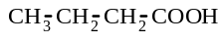 | 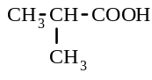 | 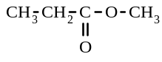 | 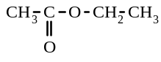
butanoic acid methylpropanoic acid methyl propanoate ethyl ethanoate

12.106 | CH₃ - CH₂ - CH₂ - CHO | CH₃ - CO - CH₂ - CH₃
butanal butanone

12.107 a) i) carboxylic acid ii) ketone iii) primary alcohol iv) secondary alcohol
v) aldehyde vi) ester vii) secondary alcohol viii) tertiary alcohol
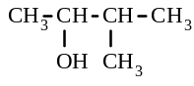
b) i) pentan-1-ol. CH₃ - CH₂ - CH₂ - CH₂ - CH₂ - OH ii) 3-methylbutan-2-ol

12.108 a) HC ≡ CH + HCl → CH₂ = CHCl b) addition reaction
c) n CH₂ = CHCl → ( CH₂ - CHCl )_{n} d) addition polymerisation reaction
H C C H
H H

H C H
O

Cl
H C H
Cl

12.109 a) b) c) d)
H C C Cl
H H

12.110 a) air, sulfur b) hydrogen, nitrogen c) animal fat, sodium hydroxide d) cryolite, bauxite

12.111 | IUPAC name | Structural formula
 | a) 2-chlorohexan-1-ol | 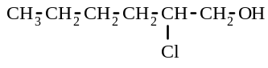
 | b) methyl propanoate | CH₃ - CH₂ - CO - O - CH₃
 | c) but-1-ene | CH₃ - CH₂ - CH = CH₂
 | d) pentan-2-one | CH₃ - CH₂ - CH₂ - CO - CH₃

12.112 a) CH₃ - CHBr - CH₂Br b) CH₃ - COOH c) CCl₃ - CCl₃ d) CH₃OH (or CH₃ - COONa)
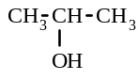
12.113 a) i) ii) CH₃ - CH₂ - O - CH₃

b) A: propanal CH₃ - CH₂ - CHO B: propanoic acid CH₃ - CH₂ - COOH

12.114 a) propanone CH₃ - CO - CH₃ b) 1,2-dibromopropane CH₃ - CHBr - CH₂ Br
c) ethyl propanoate CH₃ - CH₂ - CO - O - CH₂ - CH₃

12.115 a) (1) methyl propanoate (2) butanoic acid
b) (3) CH₃ - CO - O - CH₂ - CH₃ c) 1-propyl methanoate H - CO - O - CH₂ - CH₂ - CH₃
(or 2-propyl methanoate, or methylpropanoic acid)

12.116 | a) | 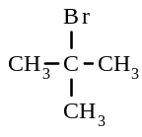 | b) | CH₃ - CO - O - CH₃ | c) | 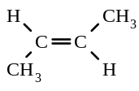

12.117. CH₃CH₂OH + H₂O → CH₃COOH + 4H⁺ + 4e Cr₂O₇²⁻ + 14H⁺ + 6e → 2Cr³⁺ + 7H₂O
Overall redox equation 2Cr₂O₇²⁻ + 16H⁺ + 3CH₃CH₂OH → 4Cr³⁺ + 11H₂O + 3CH₃COOH

12.118 a) propan-2-ol b) butanone

12.119 a) CH₃ - CH₂OH + CH₃ - CH₂ - CH₂ - COOH → CH₃ - CH₂ - CH₂ - CO - O - CH₂ - CH₃
b) CH₂ = CH₂ + HCl → CH₂Cl - CH₃

12.120 Acidified potassium permanganate solution - with the first substance, the purple colour would become colourless, with the second substance, no reaction would occur i.e. the purple colour would remain

12.121 a) H - CO - O - CH₃ b) methyl methanoate c) ethanoic acid

12.122 Oxidation half-equation CH₃ CH₂ CHO + H₂O → CH₃ CH₂ COOH + 2H⁺ + 2e
Reduction half-equation Cr₂O₇²⁻ + 14H⁺ + 6e → 2Cr³⁺ + 7H₂O
Redox equation Cr₂O₇²⁻ + 8H⁺ + 3CH₃ CH₂ CHO → 2Cr³⁺ + 4H₂O + 3CH₃ CH₂ COOH

12.123 a) b) + C₁₇H₃₅COONa
H₂C - OOCC₁₇H₃₅
HC - OOCC₁₇H₃₅
H₂C - OOCC₁₇H₃₅

H₂C - OH
HC - OH
H₂C - OH

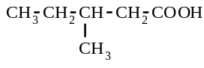
12.124 a) - CH₂ - CH₃ b) c) CH₃ - CH₂ - CHO

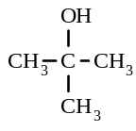
d) e) f) CH₃ - CH₂ - CO - O - CH₃
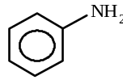

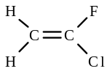
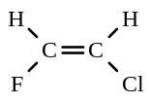
12.125 a) trans-1-chloro-2-fluoroethene b) c)

d) - CHF - CHCl - CHF - CHCl - CHF - CHCl - e) - CH₂ - CClF - CH₂ - CClF - CH₂ - CClF -

12.126. a) In first sample: moles of CO₂ = 2.109/44.01 = 0.04792 = moles of C
moles of H₂O = 0.288/18.016 = 0.01599 so, moles of H = 2 x 0.01599 = 0.03197
mass of C present = 0.04792 x 12.01 = 0.5755 g mass of H present = 1.008 x 0.03197 = 0.03223 g
mass of C in second sample = 0.5775 x 1.061/1.342 = 0.4566 g moles of C = 0.4566/12.01 = 0.03802
mass of H in second sample = 0.03223 x 1.061/1.342 = 0.02548 g moles of H = 0.02548
mole of N in second sample = 0.01263 = moles of N mass of N = 0.01263 x 14.01 = 0.1769 g
mass of O present in second sample = 1.061 - (0.4566 + 0.02548 + 0.1769) = 0.4020 g
mole of O present in second sample = 0.4020/16.0 = 0.02512
moles ratio = C : H : N : O = 0.03802 : 0.02548 : 0.01263 : 0.02512
= 3.01 : 2.017 : 1 : 1.989 = 3 : 2 : 1 : 2
i.e. the empirical formula is C₃H₂ NO₂

12.127 a) moles of CO₂ = 0.970/44.01 = 0.02204 = moles of C
moles of NaOH = 1.04 x 0.0428 = 0.04451 = moles of HCl formed = moles of Cl in compound
mass of C present = 0.02204 x 12.01 = 0.2647 g
mass of Cl present = 0.04451 x 35.45 = 1.578 g
mass of O present = 2.20 - (0.2647 + 1.578) = 0.3573 g
mole of O present = 0.3573/16.0 = 0.02233
moles ratio = C : Cl : O = 0.02204 : 0.04451 : 0.02233 = 1 : 2.020 : 1.013 = 1 : 2 : 1
i.e. the empirical formula is CCl₂O
b) PV = nRT n = = 0.03347
molar mass = 3.31/0.03347 = 98.89 g mol⁻¹ i.e. molecular weight = 98.89
molecular formula = n x empirical formula i.e. n = 98.89/98.91 ≈ 1
so molecular formula = CCl₂O
c)
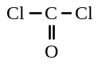

12.128 a) moles of CO₂ = 0.660/44.01 = 0.0150 = moles of C
moles of H₂O = 0.270/18.016 = 0.01499 so, moles of H = 2 x 0.01499 = 0.02997
mass of C present = 0.0150 x 12.01 = 0.1802 g mass of H present = 1.008 x 0.02997 = 0.03021 g
mass of O present = 0.290 - (0.1802 + 0.03021) = 0.07959 g
mole of O present = 0.07959/16.0 = 0.004974
moles ratio = C : H : O = 0.0150 : 0.02997 : 0.004974 = 3.016 : 6.025 : 1 = 3 : 6 : 1
i.e. the empirical formula is C₃H₆O
b) moles of O₂ = 1.00/32.0 = 0.03125 = moles of vaporised compound
molar mass of vaporised compound = 1.81/0.03125 = 57.92 g mol⁻¹
i.e. molecular weight = 57.92
molecular formula = n x empirical formula i.e. n = 57.92/58.07 ≈ 1
so molecular formula = C₃H₆O
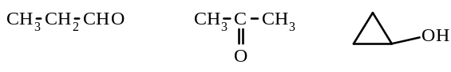
c)

12.129 a) moles of H₂O = 1.113/18.016 = 0.06178 so, moles of H = 2 x 0.06178 = 0.1236
PV = nRT moles of CO₂ = n = = 0.06176 = moles of C
mass of C present = 0.06176 x 12.01 = 0.7417 g
mass of H present = 1.008 x 0.1236 = 0.1246 g
mass of O present = 1.360 - (0.7417 + 0.1246) = 0.4937 g
mole of O present = 0.4937/16.0 = 0.03086
moles ratio = C : H : O = 0.06176 : 0.1236 : 0.03086 = 2.001 : 4.005 : 1 = 2 : 4 : 1
i.e. the empirical formula is C₂H₄O
b) PV = nRT moles of second sample of X = n = = 0.02838
molar mass of X = 2.500/0.02838 = 88.09 mol L⁻¹, i.e. molecular weight = 88.09
molecular formula = n x empirical formula i.e. n = 88.09/44.05 ≈ 2
so molecular formula = C₄H₈O₂
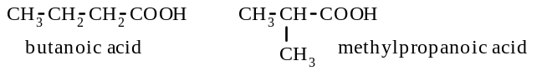
c)

12.130. a) moles of KOH = 0.0108 x 0.0200 = 0.000216 = moles of Y in the 1.0165 g L⁻¹ solution
mass of Y in this solution = 1.0165 x 0.01870 = 0.01901 g
molar mass of Y = 0.01901/0.000216 = 88.00 g mol ⁻¹
i.e. molecular weight of Y = 88.0
b) moles of CO₂ = 0.6532/44.01 = 0.01484 = moles of C in ‘Z’
moles of H₂O = 0.2672/18.016 = 0.01483 so, moles of H in ‘Z’ = 2 x 0.01483 = 0.02966
mass of C present = 0.01484 x 12.01 = 0.1782 g
mass of H present = 1.008 x 0.02966 = 0.02990 g
mass of O present = 0.2870 - (0.1782 + 0.02990) = 0.0789 g
mole of O present in ‘A’ = 0.0789/16.0 = 0.004931
moles ratio = C : H : O = 0.01484 : 0.02966 : 0.004931 = 3.01 : 6.015 : 1 = 3 : 6 : 1
i.e. the empirical formula of Z is C₃H₆O
c)
